# -----------BUSINESS ORGANISATIONS ------------

**A PROJECT REPORT**

***Submitted to***

# SAVEETHA INSTITUTE OF MEDICAL AND TECHNICAL SCIENCES

***In partial fulfillment for the award of the degree of***

# BACHELOR OF ENGINEERING IN SAVEETHA ENGINEERING COLLEGE

**By**

**CH.MOHAN REDDY**

**192110740**

***Supervisor***

# Vijay Bhaskar

# **SAVEETHA SCHOOL OF ENGINEERING**

# **SAVEETHA INSTITUTE OF MEDICAL AND TECHNICAL**

**SCIENCES, CHENNAI – 602 105.**

**BONAFIDE CERTIFICATE**

This is to certify that the project report entitled “BUSINESS ORGANISATIONS“submitted by "CH.MOHAN REDDY , REG No:- 192110740” to Saveetha School of Engineering, Saveetha Institute of Medical and Technical Sciences, Chennai, is a record of bonafide work carried out by him/her under my guidance. The project fulfills the requirements as per the regulations of this institution and in my appraisal meets the required standards for submission.

**Faculty Name** : k.vijaya bhaskar

**Designation**: professor

**Department name**: programming

# INTERNAL EXAMINER EXTERNAL EXAMINER

**DECLARATION BY THE CANDIDATE**

I declare that the report entitled **“BUSINESS ORGANISATIONS”** submitted by me for the degree of Bachelor of Engineering is the record of the project work carried out by me under the guidance of **“ k.Vijay Bhaskar”** and furthermore this work has not formed the basis for the award of any degree or diploma in this or any other University or other similar institution of higher learning.

**SIGNATURE**

# CH. MOHAN REDDY

# 192110740

## ACKNOWLEDGEMENT

This project work would not have been possible without the contribution of many people. It gives me immense pleasure to express my profound gratitude to our honorable Chancellor, **Dr. N. M. Veeraiyan**, Saveetha Institute of Medical and Technical Sciences, for his blessings and for being a source of inspiration. I sincerely thank our Vice Chancellor, **Dr. Rakesh Kumar Sharma** for his visionary thoughts and support. I am in debted to extend my gratitude to our Director, **Mrs. Ramya Deepak,** Saveetha School of Engineering, for facilitating us all the facilities and extended support to gain valuable education and learning experience.

I register my special thanks to **Prof. Dr. B. Ramesh,** Principal, Saveetha School of Engineering an **Dr. T. Maridurai,** HoD, Department of Materials, for the support given to me in the successful conduct of this project. I wish to express my sincere gratitude to my supervisor **k.Vijay Bhaskar** for his inspiring guidance, personal involvement and constant encouragement during the entire course of this work.

I am grateful to Project Coordinators, Review Panel External and Internal Members and the entire faculty of the Department of Mechanical Engineering, for their constructive criticisms and valuable suggestions which have been a rich source to improve the quality of this work.

## Ch. Mohan Reddy

## Reg.:192110740

**ABSTRACT**

Purpose/Aim :-

1) What are the various forms of Business Organisations.

2) Advantages and disadvantages of business organisations.

Business organization, an entity formed for the purpose of carrying on commercial enterprise. Such an organization is predicated on systems of law governing contract and exchange, property rights, and incorporation. corporate governance corporation public enterprise nationalization joint venture.Business enterprises customarily take one of three forms: individual proprietorships, partnerships, or limited-liability companies (or corporations). In the first form, a single person holds the entire operation as his personal property, usually managing it on a day-to-day basis. Most businesses are of this type. The second form, the partnership, may have from 2 to 50 or more members, as in the case of large law and accounting firms, brokerage houses, and advertising agencies. This form of business is owned by the partners themselves; they may receive varying shares of the profits depending on their investment or contribution. Whenever a member leaves or a new member is added, the firm must be reconstituted as a new partnership. The third form, the limited-liability company, or corporation, denotes incorporated groups of persons—that is, a number of persons considered as a legal entity (or fictive “person”) with property, powers, and liabilities separate from those of its members. This type of company is also legally separate from the individuals who work for it, whether they be shareholders or employees or both.

Result:- All organizations exist to fulfil a specific purpose and they need to be managed effectively to fulfil their purpose.

Conclusion :- Organizations can function within a number of different structures, each possessing distinct advantages and disadvantages. Although any structure that is not properly managed will be plagued with issues, some organizational models are better equipped for particular environments and tasks.

**Introduction**

# Business organisations:-

# 

Organizations are divided into two parts: Part one is trading organizations and Part two is Non Trading organizations. Trading organizations main concepts are earning a profit; it is the main motive of business. In other words, Non trading concern main concepts are rendering services to society. We will know the main issues that are related to profit, it is a main motive of business.

* For every kind of business organization, profit is often regarded as motive for the entrepreneurs and it measures the overall performance of the business.
* Profit is the tool for measuring and evaluation of the business efficiency and productivity at the managerial competence.
* It is helpful to strategic managers how to take good decisions and actions which are turn into effective in the form of able to combine and utilize the available resource and able to sustain the organization with growth and survival of the business entity.

When you start a company, one of the first steps is to choose the type and structure of your business. Regardless of the business domain that your organization operates in, the business type has a direct impact on its long-term success. Choosing the right type of business is an essential step, but it requires knowledge regarding the different types as well as an estimate of the size and structure of your business. .

Starting a business can require a lot of work, time and money.You want to make sure you prepare thoroughly before starting a business, but realize that things will almost certainly go awry. To run a successful business, you must adapt to changing situations.

**Types of business organisations:-**

**Before you decide what type of business organization to choose, assess your company to determine its general business type. Depending on what you sell, there are typically three different types of businesses.**

### **1.Sole proprietorship**

**A sole proprietorship is a type of business where there is no legal distinction between the business entity and its owner so it best fits situations where the organization only has one owner. It is a popular choice for small businesses due to the low initial costs. Also, any generated income is only taxed once instead of being taxed as a company and then again as a personal source of income. They are also subjected to less taxation and regulation compared to other types of businesses.**

### Advantages:-

Choosing to run a sole proprietorship can have many advantages, especially for small businesses. The following are a few of the benefits that choosing to start a sole proprietorship can provide:

Free to start: Unlike other types of businesses, a sole proprietorship is typically completely free to start. This can be beneficial for individuals wishing to turn a side hustle into a more lucrative career or who do not have the funds to set up another type of business.

Full control: Individuals who own sole proprietorships are the sole owners of the company and have the complete and final say as to how it is run.

Control over all revenue: Unlike other businesses that may be required to make payouts to lenders, investors and other organizations or individuals, a sole proprietorship does not have any financial obligations besides those incurred by the owner.

Ability to use losses on personal tax returns: Individuals who own sole proprietorships are required to include the income and losses of the business on their personal tax returns. This means that the losses of the sole proprietorship can be used to offset other personal income for a higher tax return.

DISADVANTAGES:-

While there are certain advantages that come with starting a sole proprietorship, there are also disadvantages to consider when deciding if a sole proprietorship is right for you. Here are a few potential disadvantages to keep in mind when determining if this type of business is your best choice:

Personally liable for lawsuits: Sole proprietors are personally responsible for all aspects of the company's financial situation. This means that if the company is in debt and unable to pay lenders, the lenders can bring lawsuits against the individual who owns the sole proprietorship. If these lawsuits are settled in favor of the lenders, the business owner will be held personally responsible to pay for the debts.

Limited options for raising capital: Whereas other types of companies can sell an interest in the business to raise capital, a sole proprietorship cannot. This can limit a sole proprietor's ability to bring in capital when it is needed.

Higher taxes: Individuals who own sole proprietorships are responsible for paying the income tax and self-employment tax for the business's income. This can be a hefty fee if the sole proprietorship is successful.

### 2.PARTNERSHIP

A partnership is a formal agreement between two or more individuals to run a business together. It can also be established between two or more businesses or between businesses and individuals. The partnership agreement clearly states the amount of authority, potential profits and liabilities that each partner is due. Although the partners share benefits and responsibilities, one partner's choices can potentially affect the entire company.

There are three types of partnerships—general, limited and limited liability partnership (LLP). In a general partnership, all partners assume liability for the company's potential losses, debt and other obligations. In a limited partnership, some of the partners are solely investors who have no managerial control or liability. LLPs are similar to general partnerships, where multiple partners are each responsible for the operations of the business. However, partners in LLPs are not personally responsible for the actions of other partners or the debts of the business. This type of business is often restricted to certain professions, such as lawyers or accountants

Limited partnership

There is a similarity between a limited partnership and a general partnership, but a limited partnership allows several people called '‘limited partners'' to become investors. With a limited partnership, limited partners have no control over the business and are not responsible for the same liabilities as general partners. A limited partnership offers advantages like:

Protection of personal assets: There is liability protection of the company's investments.

Investment opportunities: In a limited partnership, you can add more limited partners to generate more capital investments.

Complete control: The partners have full management control of how to run the limited partnership.

Pass-through taxation: With a limited partnership, the profits and losses the business earns is ‘passed through' to the partners and reported on their individual tax returns.

Limited liability partnership

This is a type of partnership that offers protection to the personal assets of the partners. If the partnership doesn't succeed, creditors cannot interfere with the partners' income or personal assets. A limited liability partnership also protects the partnership's name by preventing another company or partnership from registering a similar name.

ADVANTAGES OF PARTNERSHIP:-

There are various advantages a partnership offers, like increasing the credibility and image of your business. Other advantages include:

Low start-up costs

Increased customer base.

Ability to change your business structure due to circumstances

More resources are available

Business growth increases at a faster rate because customers are getting quality services due to your partnership.

DISADVANTAGES OF PARTNERSHIP:-

Liabilities. In addition to sharing profits and assets, a partnership also entails sharing any business losses, as well as responsibility for any debts, even if they are incurred by the other partner. ...

Loss of Autonomy. ...

Emotional Conflict. ...

Future Selling Complications. ...

Lack of Stability.

**3.HINDHU UNDIVIDED FAMILY :-**

A joint family or undivided family is an extended family arrangement prevalent throughout the Indian subcontinent, particularly in India, consisting of many generations living in the same household, all bound by the common relationship.

Hindu Undivided Family (‘HUF’) is treated as a ‘person’ under section 2(31)[2] of the Income-tax Act, 1961. HUF is a separate entity for the purpose of assessment under the Act.[3] Except for Kerala, HUF is recognized throughout India.

Historically, for generations India had an unexpected prevailing tradition of the Joint Hindu Family or undivided family. The system is an extended family arrangement prevalent throughout the Indian subcontinent, particularly in India, consisting of many generations living in the same home, all bound by the common relationship.[4] A joint family consists of a husband and wife, their sons, their unmarried daughters, and their sons’ wives and children. The same pattern (sons, their wives and children, and unmarried daughters) repeats for as many generations as are currently alive. Any number of these people may without impacting the legal existence of the family, be deceased.

The family is headed by a senior person called a 'Karta', usually the oldest man, who makes decisions on economic and social matters on behalf of the entire family. Other members of the family are known as 'coparceners'.[5] The patriarch's wife generally exerts control over the household and minor religious practices and often wields considerable influence in domestic matters. Family income flows into a common pool, from which resources are drawn to meet the needs of all members, which are regulated by the heads of the family. However, with urbanization and economic development, India has witnessed a break up of traditional joint family into more nuclear-like families, and the traditional joint family in India accounted for a small number of Indian households.

A Hindu undivided family or HUF is a legal term related to the Hindu Marriage Act. The female members are also given the right of share to the property in the HUF. The term finds reference in the provisions of the Income Tax Act, but the expression is not defined in the act. There are various aspects of Hindu law relevant for the purpose assessment of income of HUF with Hindu Succession Act 1956 and Income Tax Act 1961 and wealth in the status of HUF, as well as the impact of the provisions of Hindu Succession Act 1956 as amended by Hindu Succession (Amendment) Act 2005 relevant for the purpose of assessment of income and wealth in the status of HUF under the Income Tax Act 1961.

In the case of Surjit Lal Chhabra 101 ITR 776 SC, joint family and undivided family are synonymous: "A joint Hindu family consists of persons lineally descended from a common ancestor and includes their wives and unmarried daughters. The daughter, on marriage, ceases to be a member of her father's family and becomes a member of her husband's family."

ADVANTAGES OF HINDHU UNDIVIDED FAMILY:-

You can form different taxable units of HUF. Any asset or savings made or insurance premium disbursed by the HUF will be subtracted from the net Income for the tax purpose. One of the major reason most family forms HUF is because they can create two PAN cards and file taxes separately.

A woman can be a co-partner in the HUF as her husband is a Karta. So, the additional income earned by the woman cannot be added to this. The official stature remains the same if the Karta or the last member of the family is passed.

Therefore, the ancestral and the acquired assets of the HUF will stay in the hands of the widow and need not be partitioned. An adopted child can also become a member of HUF family.

Women in the family can gift a property in her name which is owned by her or her family. Members of Hindu Undivided Family can easily avail loans. This act is recognised in pan India expect Kerala.

DISADVANTAGES OF HIDHU UNDIVIDED FAMILY:-

1. Privacy is Compromised

Lack of privacy is a common complaint among people who live in a joint family. You are never alone. If you are distressed and want to be alone and cry to let it out, you’d prefer crying in your bed and telling your sad stories to your pillow. But that’s not possible if you are living in a joint family. Everyone knows everything about all the members of the family and this leads to interference in daily matters. More often than not, this interference is not appreciated and people end up hiding things so that others mind their own business. You will always be surrounded by people and they will try to help you for your sake, but sometimes it gets too much.

2. A small Decision Runs by Everyone

The problem of living in a joint family is even a small decision has to go through and get a green signal by every member of the family, particularly the head of the family. Whether it is about going out after 7 at night or a sleepover at a friend’s place. Sometimes, even trivial matters are given so much attention that it annoys you.

3. Financial Responsibility

In a joint family, it is about ‘us’. When it comes to financial responsibility, usually, the ‘Karta’ (the head of the family) handles financial matters while other male members of the family contribute. However, many times it happens that the burden of 2 or more families is on the ‘Karta’ of the family, and other members become idle and the burden on one person only increases.

4. Interference in Parenting

Living in a joint family sometimes deprives you of taking right decisions for your child. As a mother, you might not get to parent your child the way you want to, because there will be others in the house who will keep teaching you about what to do and what not to do. This may create hindrance in your style of parenting and ultimately it fuels your anger.

### **4.co-operative society:-**

A cooperative is a legal entity owned and democratically controlled by its members. Members often have a close association with the enterprise as producers or consumers of its products or services, or as its employees.[36] The legal entities have a range of social characteristics. Membership is open, meaning that anyone who satisfies certain non-discriminatory conditions may join. Economic benefits are distributed proportionally to each member's level of participation in the cooperative, for instance, by a dividend on sales or purchases, rather than according to capital invested.[37] Cooperatives may be classified as either worker, consumer, producer, purchasing or housing cooperatives.[38] They are distinguished from other forms of incorporation in that profit-making or economic stability are balanced by the interests of the community.[37]

There are specific forms of incorporation for cooperatives in some countries, e.g. Finland[39] and Australia.[40] Cooperatives may take the form of companies limited by shares or by guarantee, partnerships or unincorporated associations. In the UK they may also use the industrial and provident society structure. In the US, cooperatives are often organized as non-capital stock corporations under state-specific cooperative laws. Cooperatives often share their earnings with the membership as dividends, which are divided among the members according to their participation in the enterprise, such as patronage, instead of according to the value of their capital shareholdings (as is done by a joint stock company).

CO-OPERATIVE SHARE CAPITAL

The cooperative share capital or co-operative share capital (in short cooperative capita or co-operative capital) is the form of capital that the cooperative accumulates from the paid participation shares of its members.The total amount of participation shares the paid to the cooperative constitutes the cooperative capital.[44] The co-operative share capital is usually non-withdrawable and indivisible to the cooperative members.

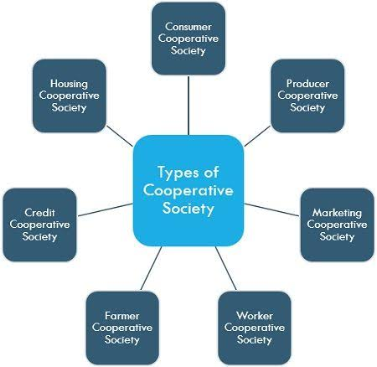

Advantages of co operative society:-

Co-operatives are democratic organisations, focused on delivering their mission to their members rather than maximising return to investors. Consider a co-op when you have at least five eligible members.

A co-operative is a democratic organisation, owned and controlled by its members for a shared benefit. It is a distinct legal entity from its members or officers.

In Australia, the types of co-operative are:

‘Distributing co-operative’: has shares and can distribute profits to members based on level of use of the co-op’s services, or their shareholding.

‘Non-distributing co-operative’: may or may not have shares and cannot distribute profits to members. Profits are re-invested into improved products and services.

DISADVANTAGES OF CO OPERATIVE SOCIETY:-

Members have equal voting rights regardless of investment - which may not suit an investor-driven business

legal limits on payments of dividends on shares may not suit an investor-driven business

### 5.COMPANY

A company, abbreviated as co., is a legal entity representing an association of people, whether natural, legal or a mixture of both, with a specific objective. Company members share a common purpose and unite to achieve specific, declared goals.

voluntary associations, which may include nonprofit organizations

business entities, whose aim is generating profit

financial entities and banks

programs or educational institutions

A company can be created as a legal person so that the company itself has limited liability as members perform or fail to discharge their duty according to the publicly declared incorporation, or published policy. When a company closes, it may need to be liquidated to avoid further legal obligations.

Companies may associate and collectively register themselves as new companies; the resulting entities are often known as corporate groups.

TYPES OF COMPANIES:-

company limited by guarantee

company limited by shares

A company limited by guarantee with a share capital

limited liability company

unlimited company

Statutory companies

A company limited by guarantee (CLG): Commonly used where companies are formed for non-commercial purposes, such as clubs or charities. The members guarantee the payment of certain (usually nominal) amounts if the company goes into insolvent liquidation, but otherwise, they have no economic rights in relation to the company. This type of company is common in England. A company limited by guarantee may be with or without having share capital.

A company limited by shares: The most common form of the company used for business ventures. Specifically, a limited company is a "company in which the liability of each shareholder is limited to the amount individually invested" with corporations being "the most common example of a limited company".[9] This type of company is common in England and many English-speaking countries. A company limited by shares may be a publicly traded company or a privately held company.

A company limited by guarantee with a share capital: A hybrid entity, usually used where the company is formed for non-commercial purposes, but the activities of the company are partly funded by investors who expect a return. This type of company may no longer be formed in the UK, although provisions still exist in law for them to exist.[7]

A limited liability company: "A company—statutorily authorized in certain states—that is characterized by limited liability, management by members or managers, and limitations on ownership transfer", i.e., L.L.C.[9] LLC structure has been called "hybrid" in that it "combines the characteristics of a corporation and of a partnership or sole proprietorship". Like a corporation, it has limited liability for members of the company, and like a partnership it has "flow-through taxation to the members" and must be "dissolved upon the death or bankruptcy of a member"

An unlimited company with or without a share capital: A hybrid entity, a company where the liability of members or shareholders for the debts (if any) of the company are not limited. In this case, the doctrine of a veil of incorporation does not apply.

Statutory companies: Relatively rare today, certain companies have been formed by a private statute passed in the relevant jurisdiction.

When "Ltd" is placed after the company's name, it signifies a limited company, and "PLC" (public limited company) indicates that its shares are widely held.[11]

In the legal context, the owners of a company are normally referred to as the "members". In a company limited or unlimited by shares (formed or incorporated with a share capital), this will be the shareholders. In a company limited by guarantee, this will be the guarantors. Some offshore jurisdictions have created special forms of offshore company in a bid to attract business for their jurisdictions. Examples include segregated portfolio companies and restricted purpose companies.

ADVANTAGES OF COMPANIES:-

Advantages of a company include that:

liability for shareholders is limited

it's easy to transfer ownership by selling shares to another party

shareholders (often family members) can be employed by the company

the company can trade anywhere in Australia

taxation rates can be more favourable

you'll have access to a wider capital and skills base.

DISADVANTAGES OF COMPANIES:-

Disadvantages of a company include that:

The company can be expensive to establish, maintain and wind up

the reporting requirements can be complex

your financial affairs are public

if directors fail to meet their legal obligations, they may be held personally liable for the company's debts

profits distributed to shareholders are taxable.

**Literature survey**

**Business organisations impacts on Indians:-**

India is going through a period of unprecedented economic liberation, opening its vast consumer base to international firms. However, it is a notoriously difficult place to do business, and having local help on board is the key to unlocking the country’s vast economic potential.

India is an enormous country with vast economic potential, but traversing the diverse and complicated corporate landscape can be a daunting task without the right help on board.

Not only is India one of the fastest growing countries in the world, it is also going through a period of unprecedented economic liberation, granting overseas investors more access to its vast and varied market than ever. A large, young population and a strong export sector await expanding businesses, with a potential consumer base that far outstrips most other nations in the developed and developing world.

Political stability and broad consensus on reforms is also a big pull for expanding companies, and the well developed banking system and vibrant capital market highlight the maturity of its financial system. But doing business in India can still be a troublesome endeavour, and having local help can really make the difference to the success of your venture.

**A specific top 10 challenges of doing business in India:-**

Starting a Business

The cost of starting a business in India is astronomical, and the procedures involved can be daunting without local knowledge. There are 12 procedures to complete in the initial set up of a business costing 49.8% of income per capita. It takes almost a month (27 days) to complete the tasks on average, which is well above the OECD average of 12 days.

Dealing with Construction Permits

Construction permits are also a costly pursuit, involving 34 procedures and taking 196 days. Obtaining Intimation of Disapproval from the Building Proposal Office and paying fees takes around a month, and NOCs must be sought from the Tree Authority, the Storm Water and Drain Department, the Sewerage Department, the Electric Department, the Environmental Department, the Traffic & Coordination Department and the CFO.

Getting Electricity

The cost of getting electricity is relatively cheap in comparison to the rest of South Asia, but the number of procedures involved can be rather daunting. What’s more, each procedure is in itself quite time constraining, taking around eight days to receive an external site inspection and three weeks to get externally connected, have a meter installed and conduct a test installation.

Registering Property

Registering a property requires quite a bit of legwork and can also incur substantial charges. Stamp duty of 5% of the property and a 1% charge on the market value of the property incurred at the Sub-Registrar of Assurances are the two fees to look out for, although the lawyer charges and fees at the Land & Survey Office can also pinch.

Getting Credit

India performs the best of all South Asian economies for ease of getting credit, ranking 23rd in the world according to the World Bank and International Finance Corporation. The 2013 report this to when a “unified collateral registry, which is centralised geographically, became operational in India strengthening access to credit and the secured transaction regime”.

Protecting Investors and enforcing contracts

The concept of investor protection is one that has garnered a lot of attention of late, and new bodies such as the Securities and Exchange Board of India (SEBI) have been set up to that effect. Enforcing contracts will also be an area that must be looked at; India ranks as one of the worst countries in the world for the ability to enforce a contract, taking an average of 1,420 days.

Paying Taxes

Businesses operating in India are required to make 33 tax payments a year, taking 243 hours’ worth of attention. The headline corporation tax rate stands at 30%, but companies can also incur charges in the form of a central sales tax, dividend tax, property tax, fuel tax, vehicle tax, VAT and excise duty.

Trading Across Borders

Despite India opening its borders to international trade, there are still several hurdles to overcome when importing and exporting goods. Several layers of bureaucracy make it very challenging to move goods efficiently, and companies must file a long list of documents before moving goods across borders.

Resolving Insolvency

It takes 4.3 years to resolve insolvency in India, far longer than the South Asian and OECD average. The laborious court system can often slow business relations.

Culture

India is a cultural hotbed, and business is more about building relations than presenting figures and sums. The polychronic culture can be difficult to adapt to for outsiders, and due diligence into the destination is important before travelling.

Culture

India is a cultural hotbed, and business is more about building relations than presenting figures and sums. The polychronic culture can be difficult to adapt to for outsiders, and due diligence into the destination is important before travelling.

TMF Group

We have the local knowledge to help you navigate these minefields. Whether you want to set up in India or just want to streamline your Indian operations, talk to us.

**Google survey form**

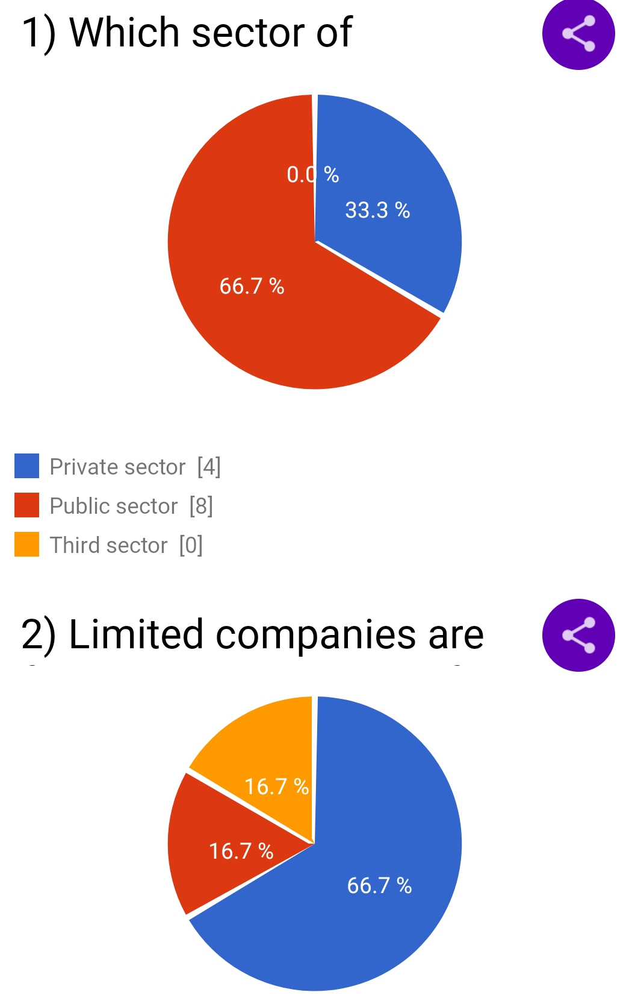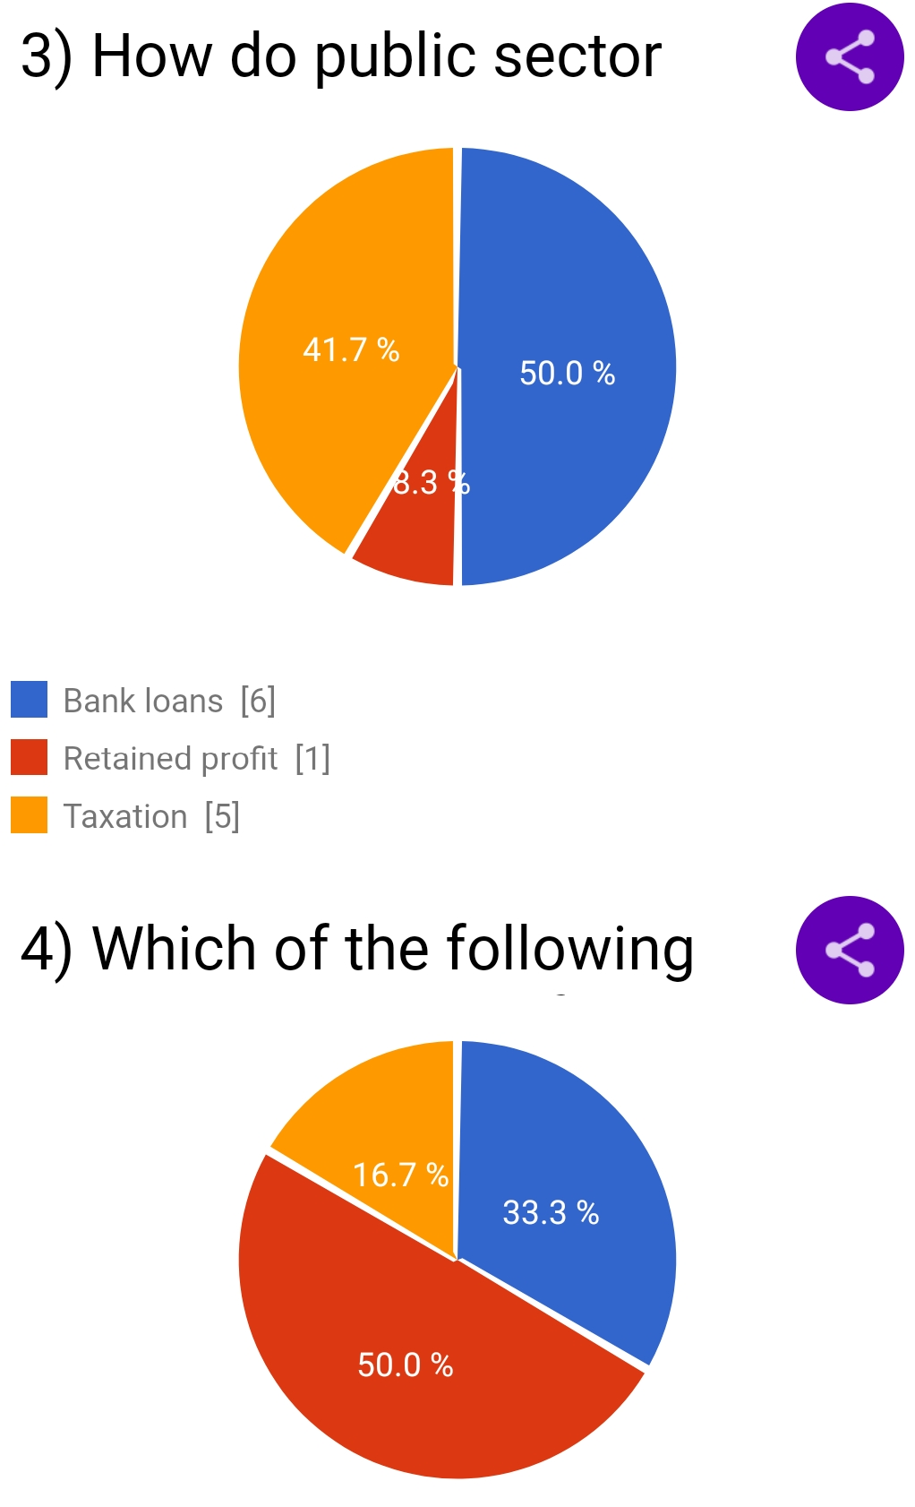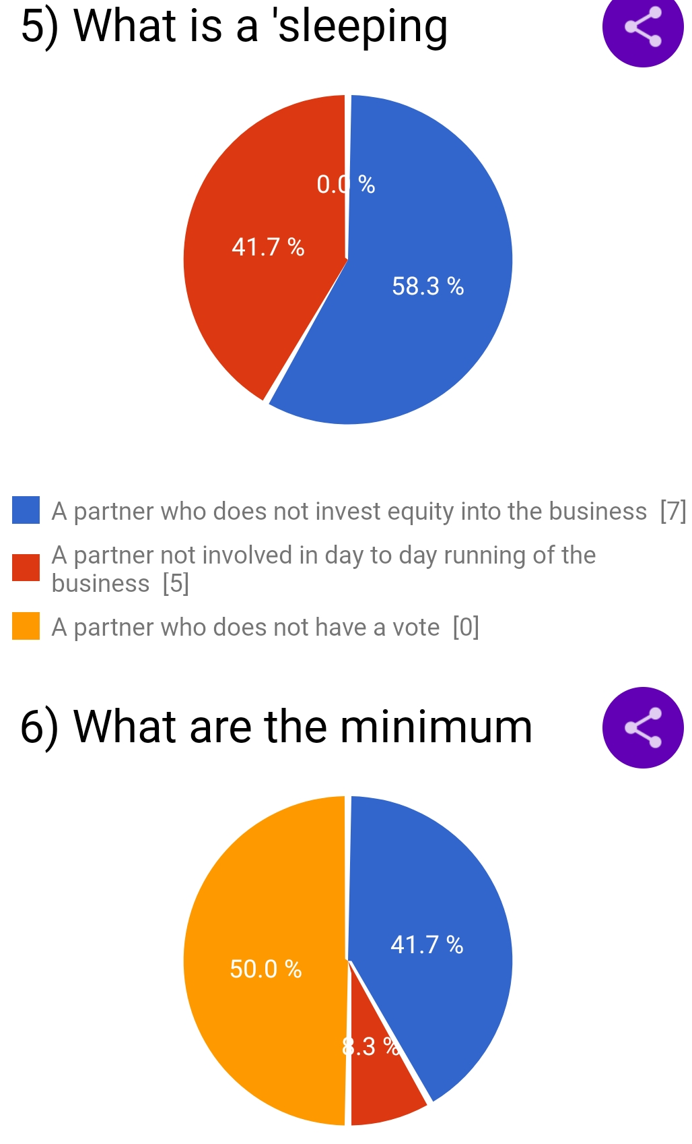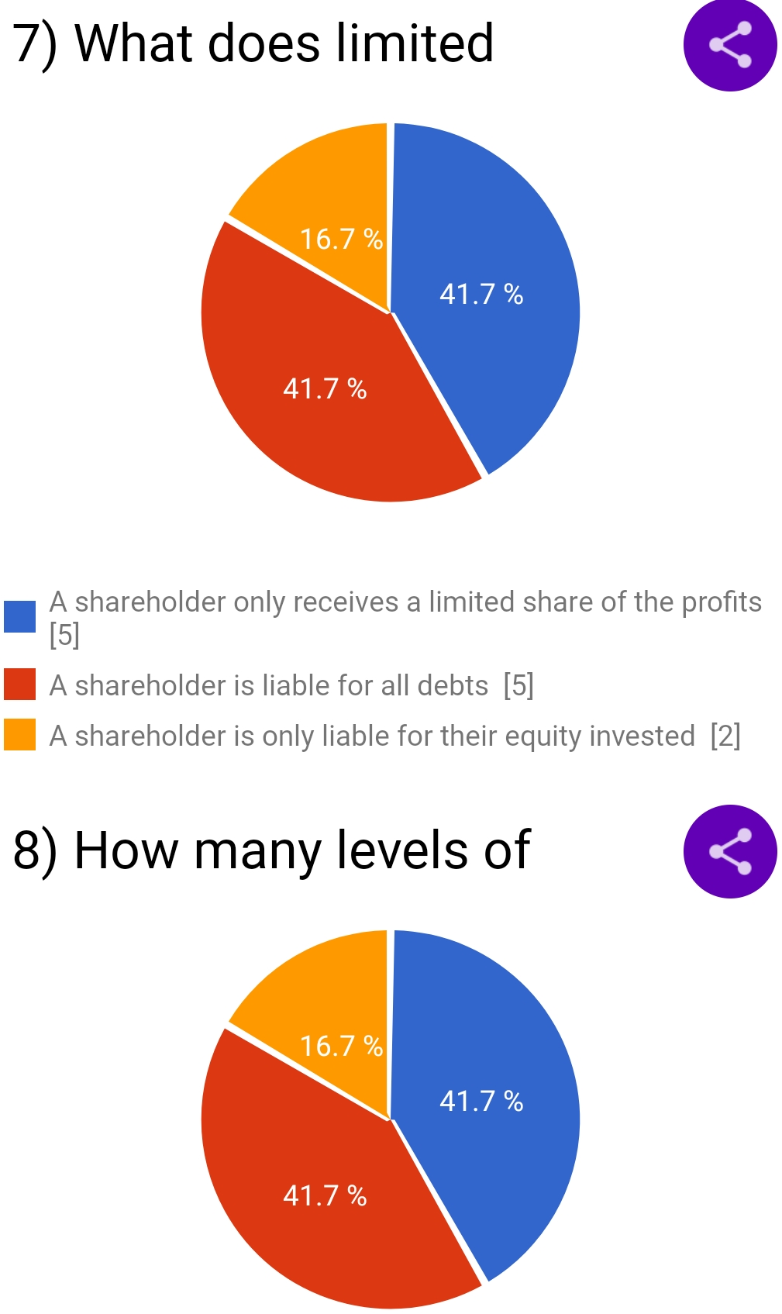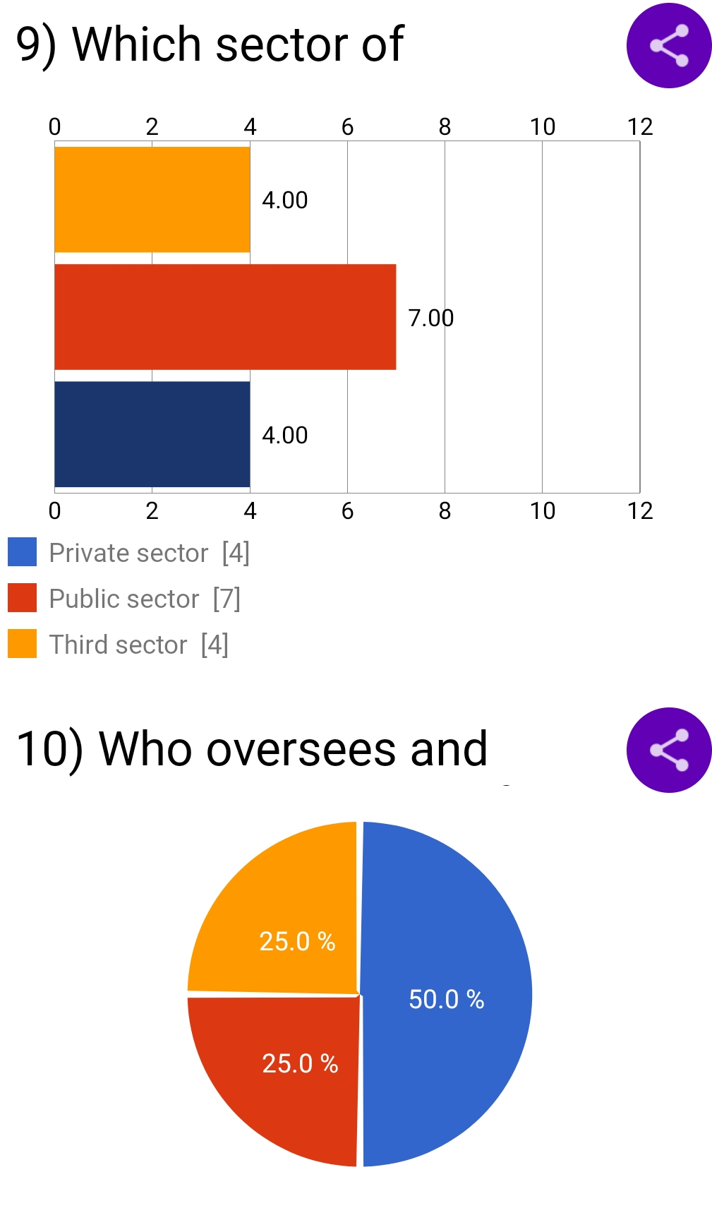

**Discussion :-**

The India business landscape is prepared to grow in multiple areas due to several factors such as international trade, government stimulus, and an overall strong developing country. With a young population that is rising to leadership and technology driving growth and innovation, there are several business opportunities in multiple sectors that we are going to explore today.

For each business idea, I am going to talk a bit about the opportunity behind it, its startup cost potential, and where you can get started to execute. There is bound to be a successful business idea in here for you.

**Sugesstions:-**

### 1.Organize Your Processes and Workspace:-

The deeper you get into your business, the more cluttered it can become–literally. You may have things such as paperwork spread across your deck, an unsorted Google Drive, and subscription services with old payment details. Your goal to improve business becomes easier when you implement more organization and efficiency.

1. Revisit Your Finances:-

To improve business, you need to know financial numbers like the back of your hand. This includes everything from cash flow to your business’s credit score. Cash flow is a key indicator of growth or early failure, with 46% of small businesses exiting with irregular cash flows.By revisiting your finances, pay close attention to the accuracy of numbers and determine where you may be spending egregiously. Where are you spending where you should be saving? The only way you can identify financial improvements is by knowing your numbers.

1. Connect With Your Community

Do you remember how you vigorously hunted for customers in the early days? Chances are that spark has dimmed over time, and you may have lost contact with customers to focus on other aspects of the business.

Reengaging with your community is a necessary and fulfilling method to enhance business. In fact, 86% of loyal customers will refer others to a business, furthering the community around brands.4 You can tap into this method by finding new ways to connect with customers, including:

Virtual meetups with loyal customers

Farmer’s-market tables for attracting local consumers

Live social media videos, sharing tips or fun content

Monthly emails to customers with updates

1. Connect With Your Employees

Your employees are also influential on your path to improving business. Creating a positive work environment for your team encourages motivation, productivity, and fresh ideas.

Employees seek out workplaces where they feel valued and respected, and you can implement strategies to create spaces for intentional conversation and celebration. This could be anything from an open-door policy between you and employees to quarterly team feedback meetings and birthday or holiday greetings.

1. Consider Acquisitions and New Development

A great way to focus on business development is by looking around. Your market is full of inspiration and insightful data, such as a new niche, a trend, or a competitor. You may pinpoint a struggling business that could be open for a buyout, a potential opportunity to break into a new clientele.

You should also aim to diversify your product lines based on the results of your research. The social world has made it easy to stay aware of trends, especially on TikTok, with its 1 billion users.5 This is a great way to keep your business fresh and in the social conversation. And remember, staying on trend could simply mean marketing or branding a classic product in a new way.

1. Know When You Need Support

The final method to improve business may be a hard lesson for some headstrong business owners. But you need to get comfortable knowing when you’re out of your league and ask for guidance.As you build out the business, strive to put together an advisory board, formally or informally. Identify individuals whom you feel comfortable with and who know the business and industry. Having a trusted group to go to for advice makes a difference.

But at the end of the day, the key activity you can do to strengthen your business is taking a break. Hitting a plateau offers a time to reflect on your business’s progress and where you see its future.

**conclusion**

Organizations can function within a number of different structures, each possessing distinct advantages and disadvantages. Although any structure that is not properly managed will be plagued with issues, some organizational models are better equipped for particular environments and tasks. A change in the environment often requires change within the organization operating within that environment.

Change in almost any aspect of a company’s operations can be met with resistance, and different cultures can have different reactions to both the change and the means to promote the change. In order to better facilitate necessary changes, several steps can be taken that have been proven to lower the anxiety of employees and ease the transformation process. Often, the simple act of including employees in the change process can drastically reduce opposition to new methods. In some organizations this level of inclusion is not possible, and instead organizations can recruit a small number of opinion leaders to promote the benefits of coming changes.

**REFERENCES**

1. American Heritage Dictionary. Archived from the original on March 31, 2019. business [:] 1. The activity of buying and selling commodities, products, or services.
2. Vikramaditya S. Khanna. "The Economic History of the Corporate Form in Ancient India" (PDF). Archived from the original (PDF) on 2013-10-19.
3. Long, Chris P.; Sitkin, Sim B. (2018). "Control–Trust Dynamics in Organizations: Identifying Shared Perspectives and Charting Conceptual Fault Lines". Academy of Management Annals. 12 (2): 725–751. doi:10.5465/annals.2016.0055. ISSN 1941-6520. S2CID 150017645. Archived from the original on 2022-03-03. Retrieved 2020-09-05.
4. Goldberg, S. (2016). Business Technical: Wearable Devices at Work. Business Insurance, 50(2), 1.
5. Leigh, J. (2011). Economic Burden of Occupational Injury and Illness in the United States. Milbank Quarterly, 89(4), 728-772.
6. DIWAN, Jaswith. ACCOUNTING CONCEPTS & THEORIES. LONDON: MORRE.
7. Needles, Belverd E.; Powers, Marian (2013). Principles of Financial Accounting. Financial Accounting Series (12 ed.). Cengage Learning
8. Holloway, S. S.; Parmigiani, A. (2014). "Friends and Profits Don't Mix: The Performance Implications of Repeated Partnerships". Academy of Management Journal.